Name: _____________________________ Date: _______________________

What’s a Feedback Loop?
Feedback Loops are Necessary for Homeostasis  Sensors, control centers, communications systems, and targets work together in what is known as a feedback loop. Feedback is information from sensors that allows a control center to compare current conditions to a set of ideal values. In a feedback loop, information moves continuously among sensors, a control center, and a target. Most functions in the body are regulated by negative feedback loops.  Negative Feedback Loops  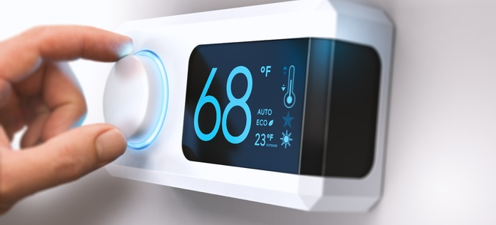  In negative feedback maintains homeostasis by counteracting any change in the body that moves conditions above or below a set point. A thermostat is a good example of how a negative feedback loop works. A sensor in the thermostat continuously measures air temperature in a room. A control mechanism detects changes to the room’s temperature. When the temperature falls below a predetermined temperature (68ºF), the thermostat sends an electronic message that turns on the furnace. When the temperature is at or just above 68ºF, the thermostat sends another message that turns off the furnace. As a result, the room always stays within a few degrees of the desired temperature. Your body’s temperature is regulated very similar to how a thermostat works.  Figure 2: A thermostat is used to control a room’s temperature  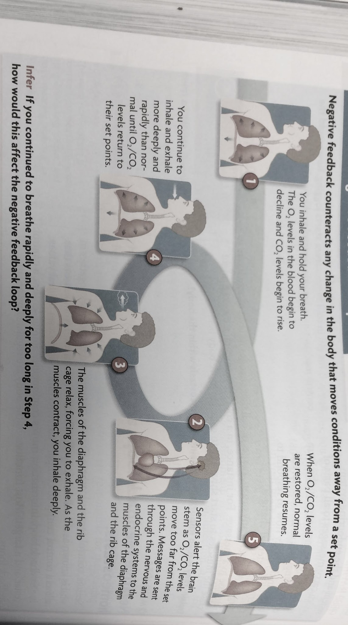  Negative feedback loops are also the reason why you cannot hold your breath for a long time. The control systems involved in this feedback loop are shown in Figure 3. As you hold your breath, sensors in the circulatory system and respiratory system send information to the brain stem, the body’s respiratory control center. Sensors signal a gradual increase in CO₂ and a decrease in O₂. The control center compares this information with the set points for these gases. When the change becomes too great, the control center takes steps to counteract it. Messages are sent to the muscles of the diaphragm and the rib cage to relax and then contract, forcing you to exhale and inhale deeply. At this point, you cannot stop these muscles from moving. You will continue to breathe rapidly and deeply until the gas levels return to their ideal points.  Figure 3: A Negative Feedback loop regulates a person’s breathing  Positive Feedback Loops  While negative feedback works by counteracting change to return a set point, there are times when the body actually needs change to occur in order to accomplish a task. In positive feedback, a control center uses information from sensors to increase the rate of change away from the set points. Though not as common as negative feedback, this type of feedback is important whenever rapid change is needed.  If you cut your finger, positive feedback mechanisms increase the rate of change in clotting factors in the blood until the wound is sealed. Once the injury heals, another positive feedback loop occurs as chemicals are released to dissolve the clot. Positive feedback also occurs in the release of certain growth hormones during puberty. Your body needs higher levels of these hormones to accomplish all of the changes that take place at this time. | Notes, Thoughts, and Questions I Have

Controlled
Acts against OR stops the change from occurring
Change or Regulate
Blood is changed from a liquid form to a solid form.

